
Patuakhali Science and Technology University
Faculty of Computer Science and Engineering

CCE 310 :: Software Development Project-I
Sessional Project Proposal

Project Title : School Manager App by flutter
Submission Date :12-10-25

Submitted by,  Mahedi Hasan Nazmul  ID : 2102013,  Reg : 10140,  Semester : 5th  (Level-3, Semester-1) | Submitted to,  - Prof. Dr. Md Samsuzzaman  Professor,  Department of Computer and Communication Engineering,  Patuakhali Science and Technology University.  - Arpita Howlader  Assistant Professor,  Department of Computer and Communication Engineering,  Patuakhali Science and Technology University.

Contents
CCE 310 :: Software Development Project-I 1
1.Title: School Manager app by Flutter 2
2. Introduction 2
2. Objectives 2
3. Problem Statement 3
4. Related Work 3
5. Scope 3
6. Methodology 4
6.1 Development Approach 4
6.2 Technology Stack 4
6.3 Design Principles 4
6.4 Development Tools 4
6.5 Timeline and Phases 5
7. System Design 5
7.1 Flow chart 5
7.2 Data flow diagram 6
7.3 Ghant chart 7
7.4 UI Design 7
8. Limitations 8
9. Result 8
10. Bibliography 9
11. Weekly Report 9

1.Title: School Manager app by Flutter

2. Introduction
Effective schedule management is crucial for schools to coordinate classes, teachers, and resources seamlessly. However, many institutions rely on outdated web-based systems like PHP/MySQL, which lack mobile accessibility and real-time updates, leading to inefficiencies and errors. The School Manager is a cross-platform mobile application built using Flutter and Firebase, enabling teachers, students, and administrators to manage schedules effortlessly on Android and iOS devices with secure authentication and offline support. This mobile-first solution enhances accessibility and user experience, addressing modern educational needs. This report details the problem, objectives, methodology, design, implementation, and outcomes.

2. Objectives
- The primary objective is to develop a cross-platform mobile application using Flutter to streamline comprehensive school management for all stakeholders. The project aims to achieve the following:
- Functional Objectives:
  - Implement secure authentication for teachers, students, administrators, accountants, staff, and school owners.
  - Enable real-time management of class routines, exam schedules, attendance, notices, assignments, and results.
  - Support dynamic assignment of teachers and subjects to classes and exam schedules.
  - Provide accounting tools for financial tracking by accountants and school owners.
- Non-Functional Objectives:
  - Ensure system responses (e.g., schedule updates, attendance tracking) load in under 2 seconds.
  - Secure user data with encrypted authentication and API calls.
  - Deliver an intuitive interface for seamless use across all user roles.
  - Support scalability for multiple users and modules on Android and iOS platforms.
- These objectives enhance accessibility, efficiency, and user experience for school management.

3. Problem Statement
Effective school management requires seamless coordination of classes, schedules, attendance, assignments, results, notices, and financial operations. However, many schools rely on outdated web-based systems, such as PHP/MySQL platforms, which lack mobile accessibility, real-time updates, and integrated functionality. These systems lead to manual errors in class routine creation, attendance tracking, and result processing, while offering limited offline support. Teachers struggle with inflexible scheduling, students lack easy access to assignments and results, administrators face inefficiencies in coordinating exams and notices, and accountants deal with error-prone financial tracking. These fragmented, inefficient processes hinder accessibility and scalability, failing to meet modern educational demands for streamlined, accurate management across diverse stakeholders, including staff and school owners.

4. Related Work
- Edmodo: A platform for classroom management, but lacks robust schedule-specific features and offline support.
- Google Classroom: Supports scheduling but is not tailored for detailed period management or teacher assignments.
- Class Timetable: A mobile app for students, lacking administrative features and real-time sync.
- My Study Life: Cross-platform but limited to student use, with minimal support for administrators.
- iSAMS: A comprehensive school management system, but expensive and not mobile-first.
The School Manager app addresses these gaps by providing a mobile-first, cross-platform solution with real-time synchronization and role-based access for all stakeholders.

5. Scope
The School Management System is a cross-platform mobile application for Android and iOS, covering management of class routines, exam schedules, attendance, notices, assignments, results, and accounting. It serves teachers, students, administrators, accountants, staff, and school owners with role-based access and offline data viewing. The initial version excludes web or desktop applications, push notifications, analytics, and full offline updates. The project focuses on delivering an integrated, mobile-first solution for comprehensive school management, addressing the needs of all stakeholders within a scalable, user-friendly framework.

6. Methodology

6.1 Development Approach
The School Management System is developed solo using an Agile methodology, adapted for individual work with iterative 2-week sprints to ensure flexibility and continuous refinement (Beck et al., 2001). Weekly self-reviews prioritize backlog tasks (e.g., offline accounting, attendance tracking), incorporating feedback from mock user testing to align with stakeholder needs (teachers, students, accountants).

6.2 Technology Stack
- Frontend: Flutter for cross-platform Android/iOS development, enabling 90% code reuse and responsive UIs via MediaQuery.
- Backend/Database: Firebase Firestore for real-time data (e.g., exam schedules, results), Firebase Storage for files (e.g., notices, assignments), and Authentication for secure role-based access.
- Offline Support: Hive for lightweight local storage of all data (e.g., schedules, accounting); Workmanager for background sync; Connectivity Plus for network detection, ensuring full offline updates with seamless online syncing.
- APIs: REST and Firebase APIs for external integrations (e.g., data exchange).
Rationale: Flutter reduces development time; Hive/Workmanager enable robust offline functionality; Firebase ensures scalability for 100+ users.

6.3 Design Principles
User-centric design, validated via Figma prototypes and Nielsen’s usability heuristics, ensures intuitive interfaces (e.g., dashboards for accountants vs. students). Responsive design adapts to diverse devices, meeting WCAG 2.1 accessibility standards.

6.4 Development Tools
- Version Control: GitHub for code versioning and feature branching.
- Project Management: Trello for self-managed task tracking and sprint planning.
- Testing: Flutter Test for unit/integration tests, including offline scenarios.
- Documentation: Markdown for API docs and user guides.

6.5 Timeline and Phases
The 14-week solo development includes:
- Weeks 1–2: Refine requirements for all modules (routines, exams, attendance, notices, assignments, results, accounting).
- Weeks 3–4: Design responsive, user-centric UI/UX via Figma.
- Weeks 5–10: Develop functionalities, prioritizing offline update logic (sprints 1–3).
- Weeks 11–12: Conduct unit, integration, and offline load testing (e.g., 100 concurrent updates).
- Weeks 13–14: Finalize deployment, documentation, and project presentation.
Evaluation: Weekly burndown charts track task completion; usability tests ensure <2s response times, aligning with objectives.

7. System Design
The System Design section visualizes the School Management System’s architecture, data flow, and user interactions to support comprehensive school management, including offline updates for class routines, exam schedules, attendance, notices, assignments, results, and accounting.

7.1 Flow chart
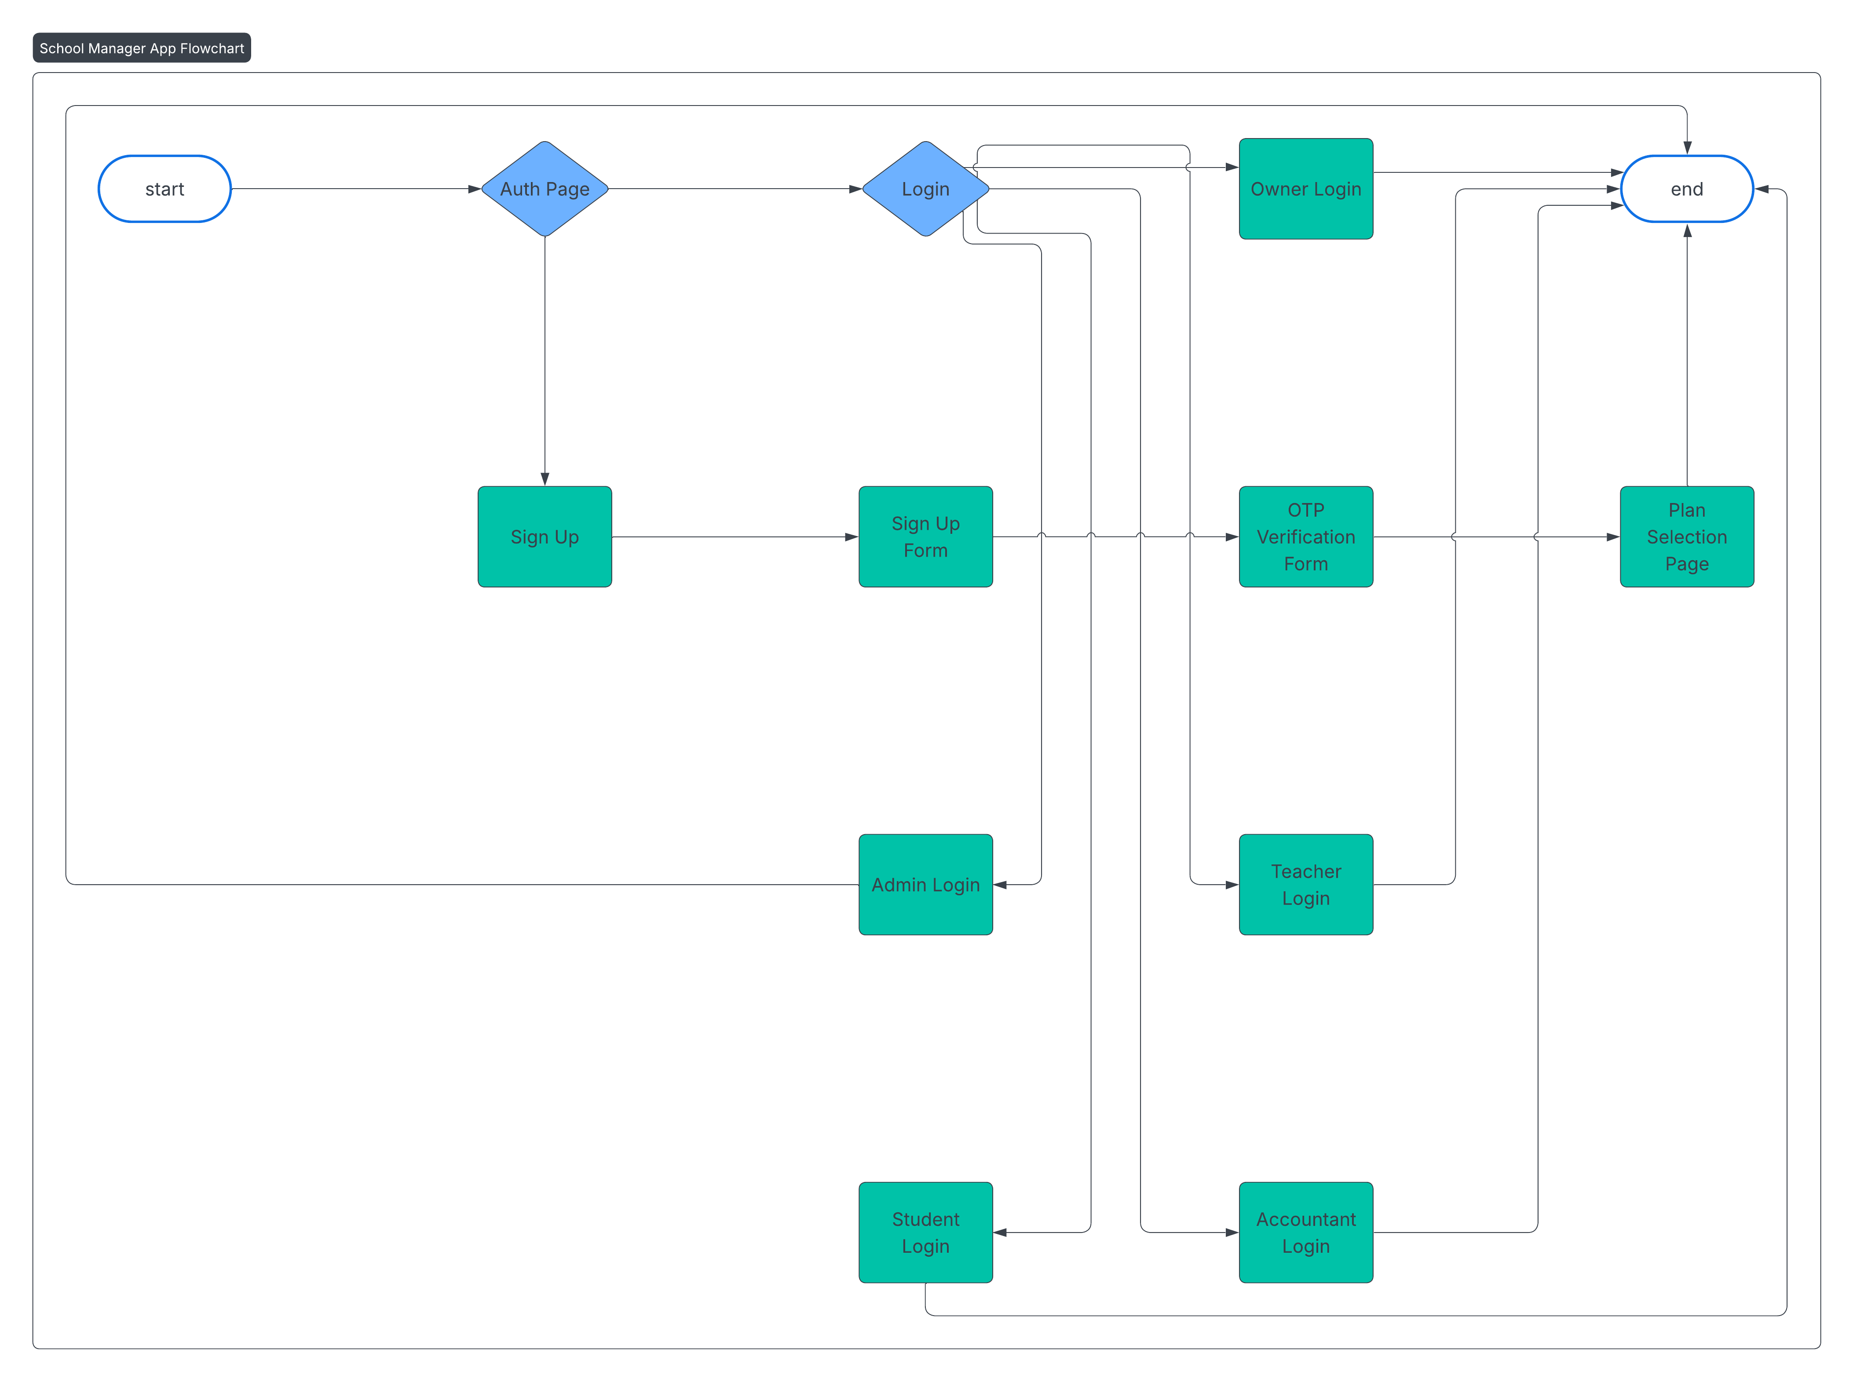
Figure 1:Flow chart of School Manager

7.2 Data flow diagram
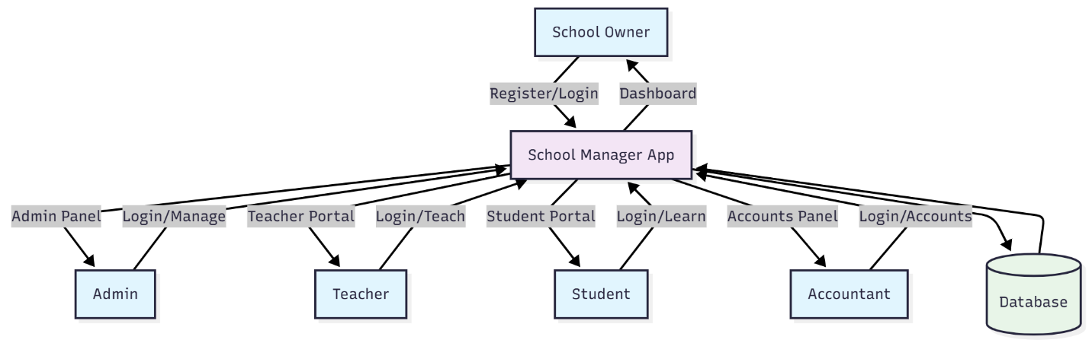
Figure 2:Level 0 DFD of School Manager

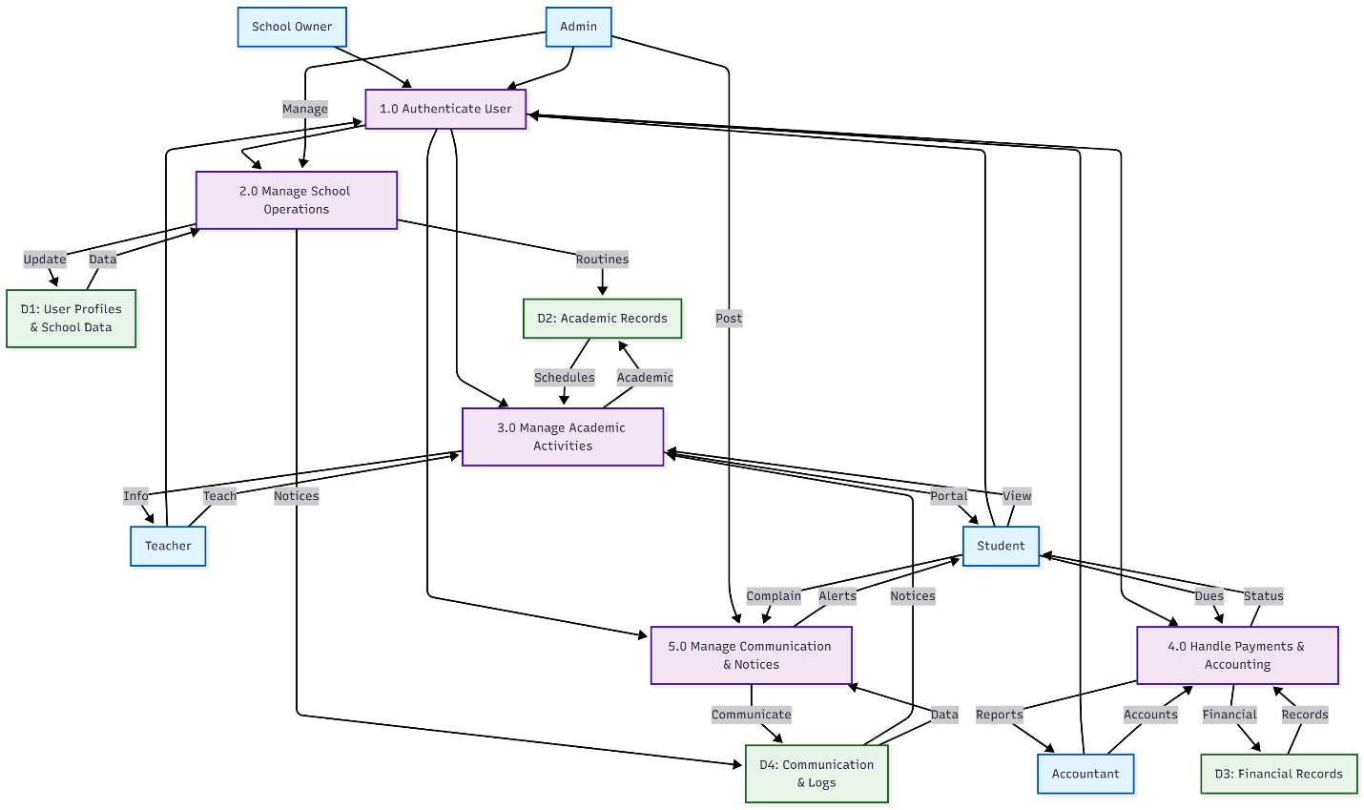

Figure 3:Level 1 DFD of School Manager

7.3 Ghant chart
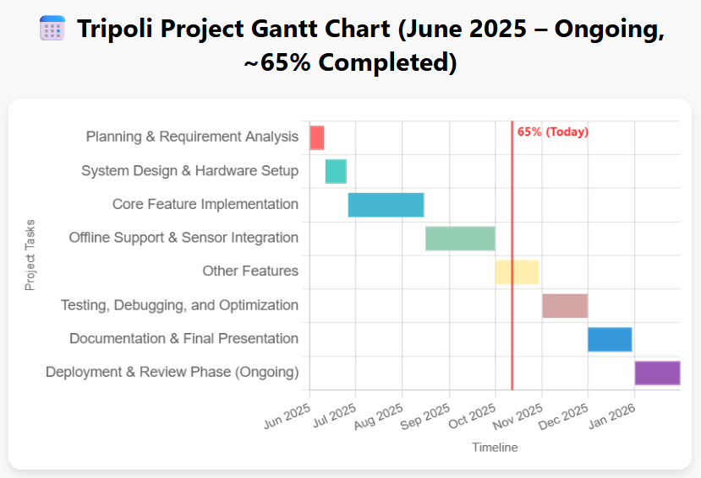

7.4 UI Design
The UI Snapshots depicts the Flutter frontend (responsive UI), Firebase backend (Firestore, Storage, Authentication), Hive for offline updates, and REST/Firebase APIs for integrations, ensuring scalability and low-latency updates.
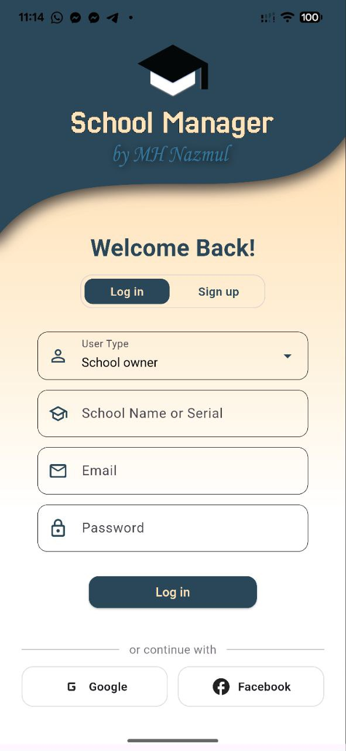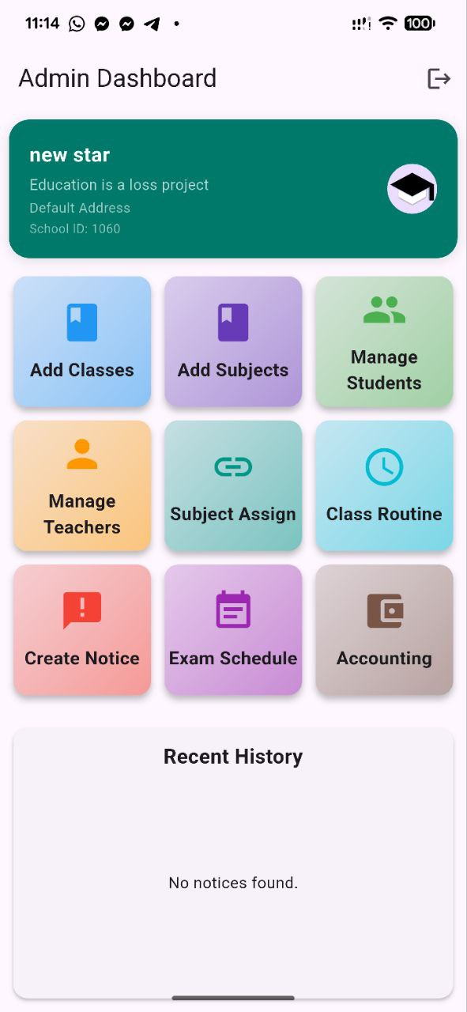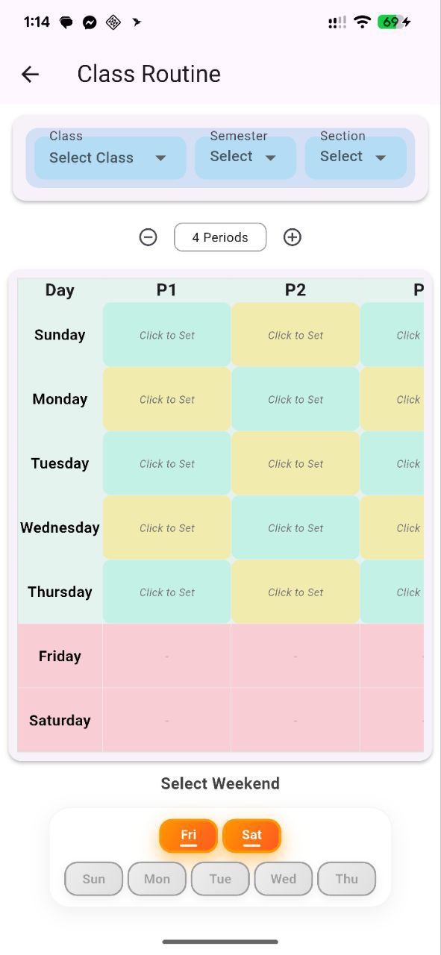

8. Limitations
- The initial version focuses on core schedule management and does not include advanced features like notifications or analytics.
- Browser-based access is not supported, focusing solely on mobile platforms.

9. Result
The School Manager will deliver a fully functional, cross-platform mobile application that enhances schedule accessibility, reduces errors, and provides a seamless user experience for teachers, students, and administrators.

10. Bibliography
[1] Martin, R. C. (2008). Clean Code: A Handbook of Agile Software Craftsmanship. Prentice Hall.
[2] Flutter Documentation. (2025). Flutter Dev Guide. Retrieved from https://flutter.dev/docs
[3] Firebase Guides. (2025). Firebase Documentation. Retrieved from https://firebase.google.com/docs

11. Weekly Report
No. | Date | Objective | Remarks
1 |  | Project proposal with initial R&D
2 | 03-08-25 | Added Login/Sign up Page
3 | 21-08-25 | Added individual dashboard to log in
4 | 04-09-25 | - Admin panner functionality:  - class management:redesigned  - Subject management:redesigned  - Teacher management:redesigned  - Student management:redesigned  - Class routine management:new  - Exam schedule management:new  - Notice management: new  - Complain management:new
5 | 01-10-25 | Added offline functionality on each feature
6 | 12-10-25 | Working on teacher dashboard.
7
8
9
10
11
12
13

